Experiment 3

Tree, Head and Tail Commands

Aim
To execute and understand the usage of tree, head, and tail commands.

Theory

head Command
Displays the first 10 lines of a file.
head filename.txt

tail Command
Displays the last 10 lines of a file.
tail filename.txt

Procedure
- Create a text file containing multiple lines.
- Execute the head command.
- Execute the tail command.
- Display directory structure using tree.

Sample Output
head student.txt
1. Arun
2. Bala
3. Kumar
tail student.txt
18. Ravi
19. Suresh
20. Priya

Output:
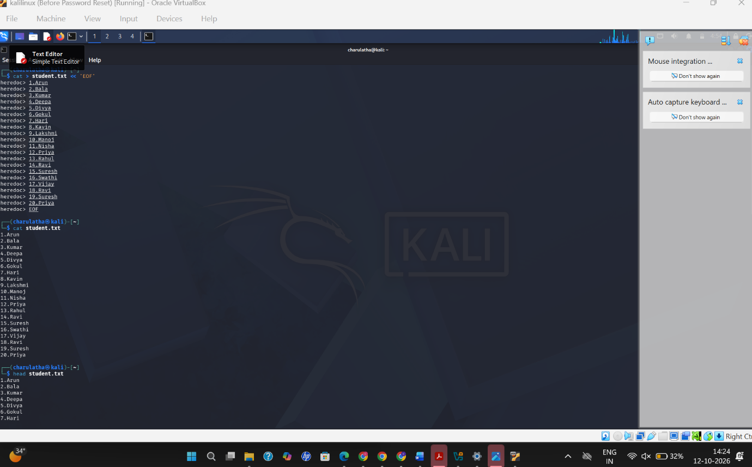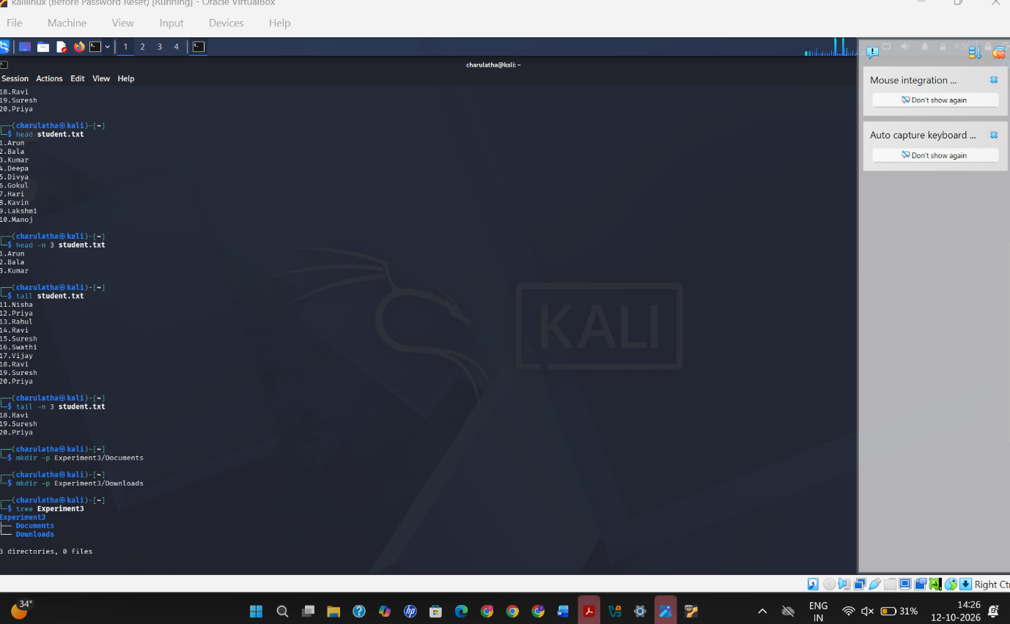

Result
Successfully executed tree, head, and tail commands.

